Chapter 1:

For a few years now, you’ve been studying at the National Academy of History and Archeology. Your classes are going well, you published a few articles on different civilizations, and even managed to land yourself a stage with a renowned historian: Professor Samuel S. who is working on a new project.

So, you now find yourself boarding a plane to Cambodia, eager to finally work on a real excavation, and discover new things. Such an opportunity isn’t an everyday occurrence, and, despite being worried you might not be experienced enough, you’re still thirsty for knowledge.

Thinking more about it, you wonder what made the professor choose you. You are not very experienced, nor are your articles on major papers, and you certainly don’t think your teachers have anything to do with it, as they would’ve tried to take your place instead of giving you this opportunity.

“Maybe he just found my papers interesting.” You think to yourself as you are driven from the airport to the hotel. “Anyway! I shouldn’t think too much about it, we have a lot of things to do tomorrow.” You grin to yourself as you think of all the things you could learn.

Finally, after a good night's sleep, the temple of Ta Prohm awaits you. As soon as you arrive you can’t help but marvel at the sight of the land. The temple is in the middle of a dense jungle. Scientists, researchers, and many workers are already on the site. The place is bustling with people, all are preparing to explore the place.

But some of them catch your attention. “Who are they?” You ask Professor Samuel, who looks in the direction you are pointing at. “Do not worry about them, they are just… *officials* of the government. Pay them no mind.” He says calmly before joining a group of other searchers.

But even with his reassuring words, you still are wary of those people. “They look like trouble. I should stay away from them.” You murmur to yourself before joining the others. But, enough resentment, now’s the time to get to work!

Once geared up, you follow the expedition in the temple. The air is crisp and cold -compared to the almost suffocating warmth you felt outside. You pace around, in awe of the intricate building. But soon enough, you stray away from the group.

You are now alone, in a cold, empty and quiet room. The way you came from is unknown to you, and the compass you brought with you doesn’t work. Four doors stand before your eyes, time to pick a path :

1

1- The first door is a stone door with an engraving in the shape of roses. Around the door, there is an arch of roses. You feel confident and calm thanks to the smell of flowers. (Go to page 2)

2- The second door is a scary and repellent door. You feel uneasy the more you watch it. It's surrounded by scarlet red blood and a very gloomy atmosphere. (Go to page 3)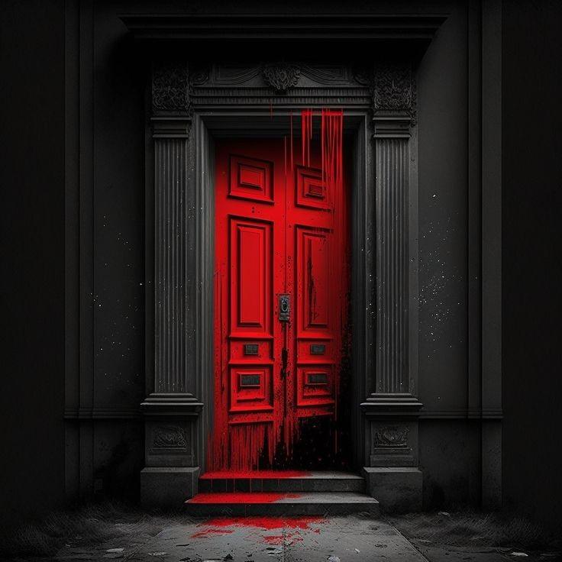

3- The third door is an elaborate medieval door. Golden leaves are engraved on its wooden panels, and an array of ivy surrounds it. (go to page 4)

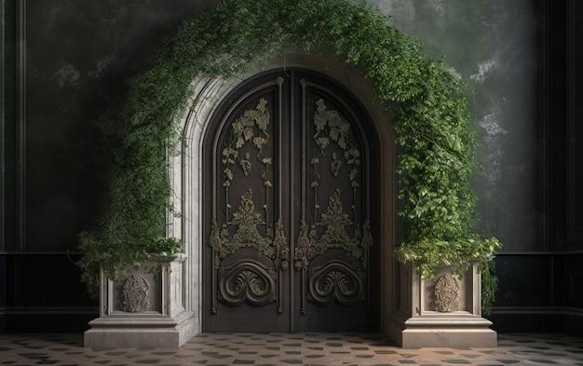

4- The fourth door is a metal orange door which displays an industrial aesthetic reminiscent of a spaceship entrance marked by wear and tear. (Go to page 5)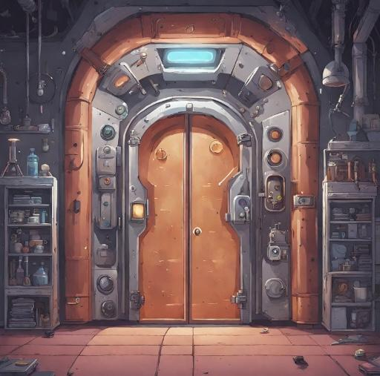

Chapter 2: Where am I?

1- You chose the first door:

You open the door and enter. You're now in a gigantic field. You look around you to discover the place. From where you stand, you can see enormous trees and beautiful flowers like dahlias, hyacinths... The environment is colorful and lush, giving you a sense of comfort.

1)You decide to explore the place (go to page 6)

2)You stay where you are (go to page 9)

2

2- You chose the second door :

You wonder if it was a good idea entering this door. But too late, you now find yourself standing among people walking and going everywhere, you feel overwhelmed by the sound and movements even though everything looks normal.

1) You try to find a way out and go to a dark narrow street (Go to page 14)

2) You enter a dull antique shop which seems closed, but the door opens… (Go to page 8)

3

3- You chose the third door:

Upon entering the door, you find yourself in a dark room. The air is moist, and cold. The door closes on its own behind you, trapping you in this room.

*1) Reach for your flashlight. (go to page 17)*

*2) Go about in the dark. (go to page 20)*

4

4- You chose the fourth door:

Once you open the door, you find yourself in the middle of a laboratory with screens all around the walls.

The door closes on its own behind you, trapping you in this room.

« Welcome to my little playground, make yourself at home. You have 1 hour..  »

You see the exit door with 3 pits, there’s no time to lose.

1. Search through the documents on the table next to you (go to page 15)
2. Look in the lockers (go to page. 18)

5

1)You decide to explore to find someone who can help you to leave this place. You see a river, you get closer and see fish of different colors: blue, gray... and different sizes. You walk along the river and see butterflies near the flowers. As you go a little further, you notice squirrels climbing in the trees. While admiring them, you hear voices so you turn around and see a group of men.

3)You go see them (go to page 11 )

4) You search for a clue (go to page 16)

6

15) You wander back to the ruins you saw earlier. A modest and run down graveyard marks the entrance to a cave. Beyond the graveyard lies a large, ragged room. Covered in rat droppings, dead insects and small bones.

Your torch allows you to see a broken arch, leading inside the dark and somber cave. Inside are three paths, you take the right. Its twisted trail leads past countless other pathways and soon you enter a worn area. Remnants of a makeshift barricade still 'guard' the group of skeletons behind it. What happened in this place?

You continue deeper into the cave. You pass many passages, some have collapsed, others are dead ends. You eventually make it to what is likely the final room. A wide wooden door blocks your path. You step closer to inspect it and.. wait.. is that a scratching sound coming from behind the door?

The fight is inevitable, as the path behind you has disappeared. You can only go onward.

You push open the door… Only to find a horrid hand-like creature.

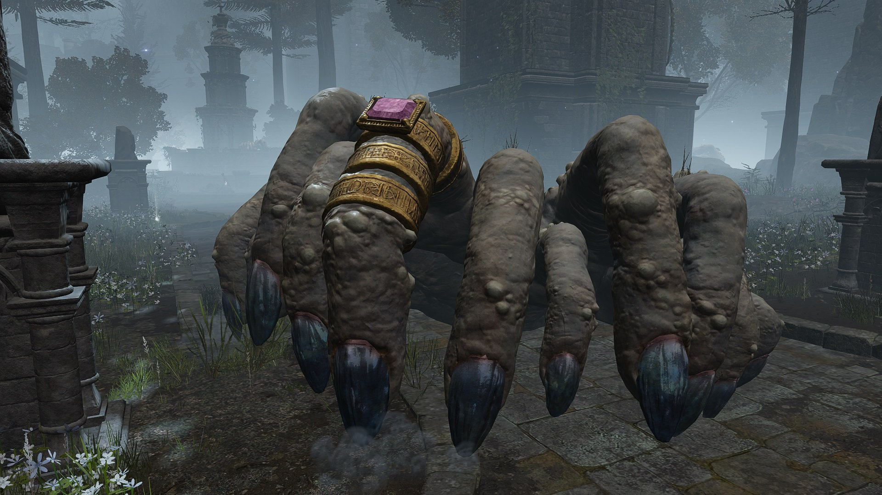

If you have the sword:

You take out your weapon, and ready yourself for the fight. The creature’s nails are scratching the floor making an unpleasant sound.

17) The fight starts. (go to page 45)

If you don’t have the sword:

Before entering the room you look around, trying to find any other way out, or something that could help you. Two choice are there:

18) A small broken down door. (go to page 42)

19) An old looking chest. (go to page 63)

7

2) As the door opens with a haunting creak, you find yourself greeted by an eerie silence. The old man behind the counter, his eyes reflecting decades of solitude, presents you two unsettling choices :

5) The old man points to a dusty Ouija board on a shelf, promising answers from the beyond. You decide to use the Ouija board to get answers (Go to page 34)

6) The old man hints at a staircase leading to the second floor. You choose to ascend the stairs (Go to page 37)

8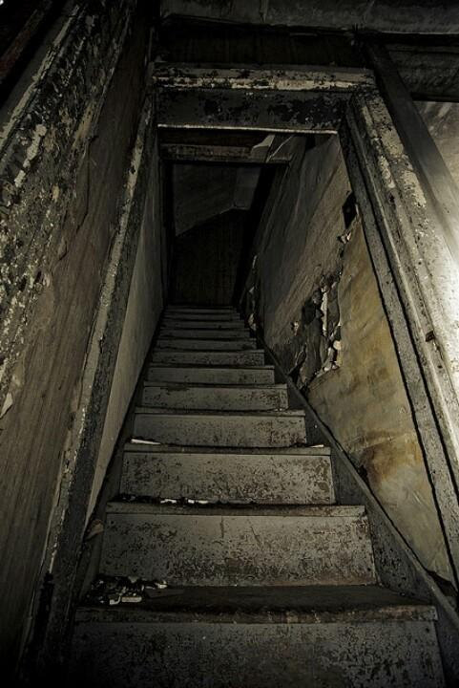

2) You decide to stay where you are and you think about how you could get out of this place and what Professor Samuel would do for you. You think for several minutes and decide to try to use your phone but there is no network so you try to look for another solution.

5) You search for a way out (go to page 13)

6) You look at the horizon (go to page 21)

9

6) If you have the torch:

- You take a closer look at the body. You can’t decipher their gender, but from their clothes you know they were some kind of priest or nun. Upon observing the corpse, something shines and reflects the light of your flame. It’s a key in their hand! You take it to the door and open it.

If you are in the dark:

-You stumble back to the cadaver, and kneel in front of it. From up close the stench is horrid, you suppress a gag and feel around to find anything of use. The feeling of the decaying flesh under your fingers is quite disgusting, but you brace yourself and eventually find a key. You take it to the door, and after feeling around you manage to open the door.

*(go to page 36)*

10

3) You’re getting closer and closer slowly. They see you coming. When you come to them, they jostle to introduce themselves first to you, which makes you laugh. The first one is Jack. He’s blond with blue eyes, he’s medium-sized and has dark glasses. The second is named Bartholome, he has a checkered shirt and round glasses. He has a book about flower breeds. The third is Dan, he’s tall, brown hair, and a little beard. you notice he’s strabismus but you find it gives him some charm. After they introduce themselves, it’s your turn to do it and you explain your adventure, that you have to get out of this place. you decide to make 3 groups to find clues.

7) You decide to go with Jack (go to page 23)

8) You decide to go with Dan (go to page 27)

9) You decide to go with Bartholome (go to page 31)

11

10) She sighs, and turns around on her mount. “I understand… May we meet again, perhaps in another world.” She then rides off on her horse, leaving you in the woods where you had fallen.

Now alone again, you take a moment to wonder what had happened. The temple, the monster, your death and now the girl. All of it was very confusing. How did you end up here? And how would you get out?

*14)Go in the same direction as the unknown woman (go to page 39)*

*15)Go to the ruins on your left (go to page 7)*

12

5) You’re looking for a way out, so you’re digging the place: the pile of leaves, the river, under the rocks… You are missing only two places that you have not looked: the first is a burrow and the second is a tree trunk quite wide.

12) You find a door (go to page 38)

13) You are in front of a tunnel (go to page 46)

13

1) As you walk through the narrow alley, you find yourself at the entrance of a small, seemingly peaceful town called Hollow Grove. The moon casts an eerie glow, and shadows dance along the narrow streets.

1. You decide to explore the town's abandoned mansion (Go to page 29)

4) You choose to invest into the dense, dark forest (Go to page 26)

14

1)As you go through pages of illegible results of nonsensical experiments of a certain Dr Marbles, you find a card :

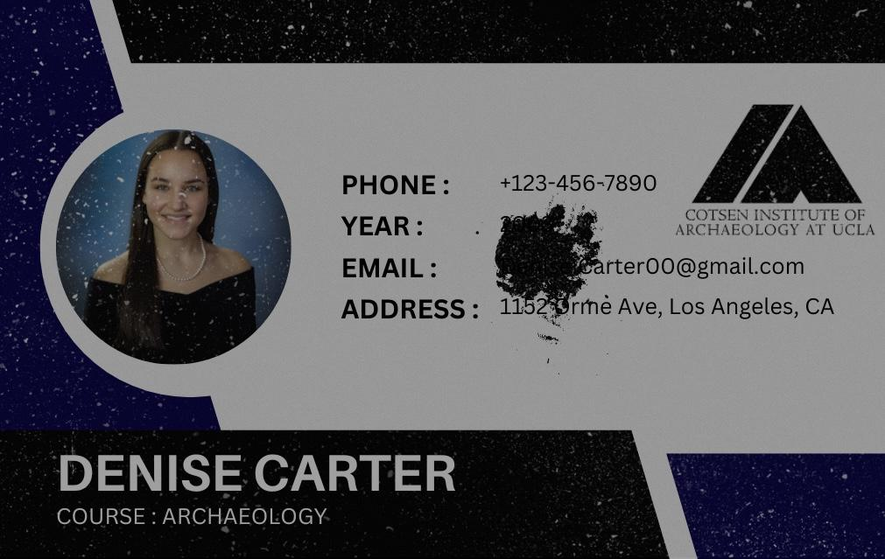

« Who is this ? » you think.

Anyway your realize that time is precious, let’s not wasting it here,

2) Look in the lockers (go to page 18)

15

4) You ignore the voices because you’re a little bit scared. You have to search for a clue to leave this place and to rejoin Professor Samuel and your colleagues to get out of the temple.

10) You search in the trunks of trees (go to page 33)

11) You search in holes made of animals (go to page 35)

16

1) You reach in your pocket, to try and find your flashlight, only to realize your clothes have changed. You are now wearing a suit of armor, and instead of a flashlight you find a torch. The torch lights up as soon as you grab it allowing you to see around you.

As the flame dances, the light reflects on the stone walls of the room. Two massive wooden doors stand in front of you.

*3) Look around. (go to page 48)*

*4) Open the doors. (go to page 19)*

17

2) You open the locker without finding anything, until on the 5th, one you finally find a blouse. You put your hand on the different pockets and find a yellow gem!

«  It mights belongs on the door”,you assume.

You decided to search a little further and find an old computer, once you tried to turn it on an error message displays on the screen: ERROR NFU78FM

3) You decide to fiddle the buttons and hope to make it work (go to page 49)

4) Let it go and try to find something somewhere else (go to page 55)

18

4) You step to the big wooden doors. You push with all your might to open them, only to be successful. The door is locked, and even with your pushes they do not move.

*4) Try again. (go to page 19)*

*6) Check the body. (go to page 10)*

19

2) As you try to walk around in the dimly lit room, you step on something. It squishes and cracks under your foot. Looking down, you can only manage to see the shadow of what looks like an arm.

Spooked and shocked you jump back with a shriek. The sound of your own scream echoes in the dark room.

*5) Keep going in the dark. (go to page 25)*

*1) Reach for your flashlight. (go to page 17)*

*6) Check the body. (go to page 10)*

20

6) You are on a hill and you look at the horizon to see if there is a significant difference. So you observe the grass, the trees, the flowers and even the animals that are present.

14) You notice that one tree is bigger than the others (go to page 40)

15) An animal approaches you (go to page 44)

21

*(after 7 or 8)*

A voice…

A gentle and quiet voice… “Rise… you are needed…”

A warm huff on your face. “If you hear me, stand up.”Slowly, your eyes open, your hand goes unconsciously to your stomach, but nothing. “You died… But, the gods pitied you. May this second life favor you…”

This time the voice is closer and louder. You look up to find a young girl riding a horned horse, who seems to be sniffing your face. She looks at you calmly from under the hood of her cloak.

“Come, I will help you…” She then holds out her hand for you to take.

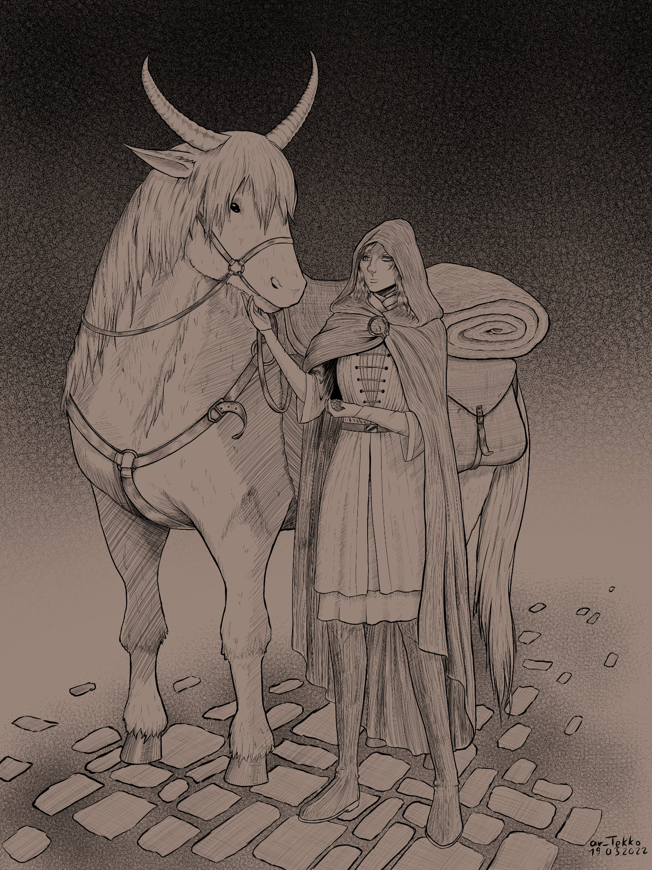

*9)Take her hand (go to page 57)*

*10)Don’t take it (go to page 12)*

22

7) You choose to put yourself with Jack and you start to get to know him better and as the conversation goes on, you realize that you have something in common with him. You convince yourself to tell him that you are beginning to like him well. But he tells you that he prefers to be friends, which creates a little discomfort between you. He still seeks to help you get out, find an exit and warn others. You manage to get out of this place and find your colleagues.

23

5) You tinker with the cuckoo clock to make the little hand point at four and the big hand point at one minute and… “COO COO” a green gem came out the bird’s mouth!

“it’s time to go” you think, you put the gems in the 3 openings that are on the door.

“Please enter the code”, you let out a sigh of despair, hoping it will be the last step .

7) Put random numbers and pray for it to open (go to page 52)

8) Search through the documents on the desk to find a clue (go to page 55)

9) Put NFU78FM (go to page 58)

24

5) This time, you are more careful as you fumble your way around. Eventually your hands touch the wall, and what feels like a door. You push, and pull but it doesn’t move.

if you keep going like this, you won’t get anywhere. You finally decide to get your light.

*1) Reach for your flashlight. (go to page 17)*

25

4) The forest is dense, and strange sounds echo among the ancient trees. But, near you, you hear the sounds of humans talking.

9) You decide to approach them (Go to page 51)

10) You pretend like you didn’t hear anything (Go to page 56)

26

8)You team up with Dan, you find him pretty interesting, but if you are totally different. You still get along well even if sometimes you don’t know what he’s talking about, like video games or cars. You spend a lot of time together to find an exit but in the end it begins to develop feelings for you. Except on your side, it’s not reciprocal so he is angry and tries to block your searches. To be forgiven for his behavior, he offers you berries that you accept but you die because it was poison.

27

7) As you turn around, a wave of fear washes over you. A creature stands behind you,

one you struggle to even describe. It looks like a kind of spider, made of human remains, all jumbled together to form a disgusting mass of flesh and bones.

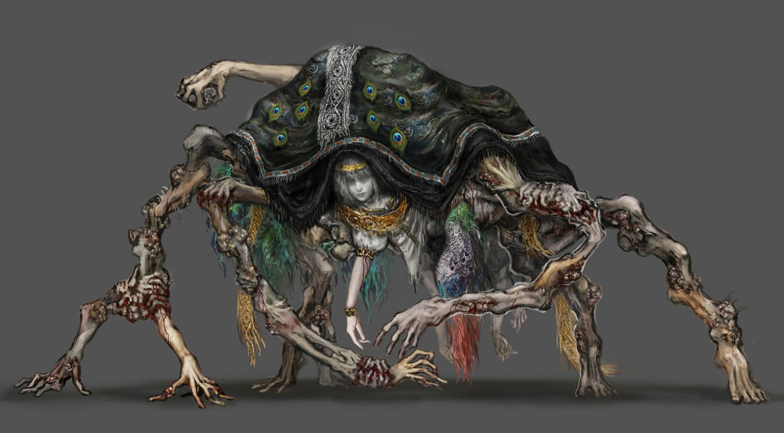

Before you even have time to scream, the beast grabs its sword and runs forward, the sword crashes into your abdomen, piercing your stomach. You fall down on your knees, blood pouring out of your wound.

YOU DIED. *(go to page 22)*

28

3) Inside the mansion, echoes of laughter and distant footsteps fill the air. A grand staircase awaits your ascent.

7) You decide to explore the upper floors (Go to page 41)

8) You decide to investigate the mansion’s forgotten ballroom (go to page 47)

29

8) Fear creeps up in your guts, and without thinking twice, you spring forward. Trying to reach the other bridge and get inside of the castle walls. But your attempt is in vain… “AAAAGH!!” You scream in pain, as a blade pierces through your body. You drop to your knees, blood pouring out of your wound.

YOU DIED. *(go to page 22)*

30

9)You go with Bartholomew and you talk to each other. You think he’s very cultured and he really wants to help you get out of this place. He tries to find solutions when you find no clues to where the exit is. you manage to find the way out. You go out and you go home but you keep in touch. You see yourself several times and you end up developing feelings for him and it’s mutual. Thanks to this adventure, you have found your soulmate.

31

12) “Well you are in the lands between… A place that once was the road to all worlds. But after our last savior died… the kingdom fell into desolation. I am sorry you have to face all this when you once could’ve been able to get home without fighting…”

*15)Go to the ruins. (go to page 7)*

*16)Go to the castle (go to page 61)*

32

10)When you look into each tree trunk, you find pieces of map. When you have found them all you sit down and you start putting the pieces back in the right place. You are finished and the map has a cross where the exit is. You try to follow the direction of the map when you jostle a man: Jack. . He helped you get up and offered his help to make amends for seeing you a little disoriented. You accept and start looking for the exit while talking and get out.

33

5) You tried to use the Ouija board with the old man's instructions, but it gave you nothing but silence. You think that he lied to you. You should try another idea to escape this haunted world.

6) You choose to ascend the stairs. (Go to page 37)

11) You give up and accept your fate. (Go to page 60)

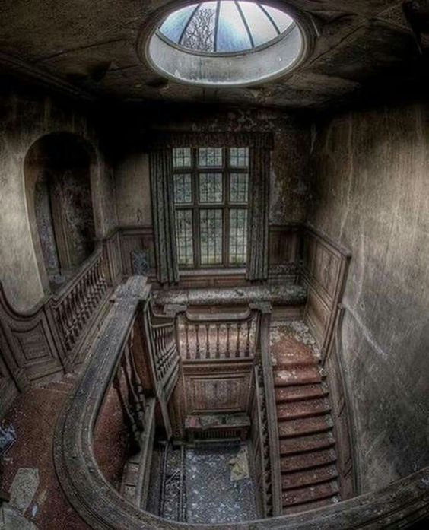

34

11)With every hole you find, you look inside if there are no clues or objects to find the exit. You find lots of rocks with numbers on them and orientations on the back. You try to understand how to do it and you deduce that you need a compass but you don’t have one. You look for a compass and a man: Bartholomew approaches you and hands you a compass. He helps you solve this riddle , after a few minutes you find the solution and the way out.

35

Next part:

The door opens up, the light blinding you for a few seconds. Once you manage to adjust to the light, you find yourself on the rampart of a castle. The sky is dark, and the clouds are yellowish. In the distance you see what looks like a behemoth of a tree, golden leaves fall from it, and its light shines brightly on the desolated land before you.

The sight is otherworldly, and you struggle to take your eyes off of it. But you can’t linger here too long, bodies of soldiers litter the floor. You walk forward, stepping over the massacre. You soon reach a wooden bridge that takes you to a small plaza on the edge of a cliff.

You cross the bridge, and stand in front of a statue situated in the middle of the square. A loud screeching noise is heard, followed by the sound of something crashing down behind you.

*7) Turn around (go to page 28)*

*8) Don’t turn and run away (go to page 30)*

36

6) You're now standing in front of 2 different doors. It reminds you of when you had to choose from 4 doors at the beginning, when you could just have walked away. The first one is horribly humid and sticky, but it seems fine, just a little old. The second one is repellent, covered in blood, just like the one you entered at first.

12) You choose to enter the normal door, where you feel the most safe. (Go to page 53)

13) You choose the gloomy door, because it reminds you of the entry. It may be the exit. (Go to page 43)

37

12)You try to open the door and you realize that behind the door is a stone wall. You see a man in the distance: Dan. You’re gonna ask him to help you break the stone wall. He takes a trunk big enough to break it, he manages to break it and the stones fall little by little until we see through it and we pass too. You leave the room to arrive next to the temple.

38

14) You follow the trail left by the horse, and find yourself in front of an old broken church. Inside is a man, sitting beside a fire and an anvil.

Walking to the man, he offers you to choose one item from his ware:

You decide to take a sword. Not anything fancy, but sturdy enough to protect you. You don’t want to get impaled…

…again…

*15)Go to the ruins. (go to page 7)*

*16)Go to the castle (go to page 61)*

39

14)You see a tree much larger and more majestic than the others. Its leaves are different and turn more towards a light green.You will look at the foot of this tree to see if there is not a clue to go out. At the foot of the tree, you find a hole wide enough for you to pass through, and when you start and go down the tunnel, you find yourself again at the starting point.(go to page 1)

40

7) The upper floors of the mansion are shrouded in darkness. Flickering candlelight reveals an old study.

14) You choose to examine the dusty books on the shelves (Go to page 62)

8) You go back to the ballroom (Go to page 47)

41

18) Opening the small door takes you to a steep flight of stairs, upon climbing them you reach a large wooden beam. You are now above the room in which the scratching sound could be heard. The sound came from a giant, hand-like monster, that was grinding its nails against the floors and doors.



From above you were able to see most of the room without being detected. And, as you look at the other side of the door, you see something written in big bold red letters: “Way out behind.” Realizing what this meant, you rush back to the stairs, but in your frenzy, you drop your torch alerting the monster. It jumps trying to catch you, but you sprint forward.

Now followed by the monster, you run as fast as you can down the stairs, trying relentlessly to find the way out the inscription mentioned. Finally, you find what looks like the exit, an opening in the cave with light at the end of it.

Without glancing back, you keep running, hearing the fast thumping of the fingers behind you. You reach the tunnel, only to realize it was a dead end, the light was just phosphorescent mushrooms. Before you know it the monster has grabbed you, crushing you to death.

YOU DIED. (go back to the beginning.)

42

13) You found an exit ! You were good for trusting your senses. You went back to the temple and found yourself on the ground. You actually had a concussion and woke up. You invented everything.

43

15) You see an animal that approaches you a little and it makes you understand that you must follow it. You approach him and he starts telling you where to go. Without realizing it, you find yourself in front of the exit. The rabbit won’t let you go, so you decide to adopt him and bring him back with you and take care of him as he did by showing you the way out.

44

17) With your sword in hand, you stand your ground. The hand creature suddenly crawls to you, making you spring into action. You dodge to the side, and slice the pinkie finger off of the monster. Blood pours out of the gaping wound, and the fallen part of finger slowly melts, turning into a puddle of goo.

The creature then jumps up, trying to crush you with its palm. You roll away just in time, and manage to not get hit. As it lays flat on the ground, you jump on it, and thrust down your blade into the back of the hand. Its fingers twist and scratch the floor in pain, before it stops moving.

Gradually, the fallen monster liquefies and is replaced with a reddish substance, then spreads into the cracks of the stone floorings. With the room now cleared of any monster, you look around, only to find writings on the door you just passed through: “Don’t enter, monsters ahead.”

“They put it on the wrong side” you grumble to yourself with a sigh. You walk around the room, touching various things that are scattered in the room. You end up finding a small crack on a stone wall, just big enough to fit your sword through it. After inserting it inside, a bright flash of light blinds you.

Once you open your eyes, you find yourself lying on the floor in the temple. The government officers surround you, and help you up. “Congratulations… you’re now a part of the group.”

GOOD END

45

13) You found a tunnel and you start venturing into it but it’s too dark so you turn around to make a torch with what you find. You need a piece of wood and to light the torch you need glasses and the sun. You see two men with glasses, approach and ask for a pair of glasses and manage to light your torch. You return to the tunnel and thus manage to move forward to exit. And when you got out you don’t remember what happened in this place.

46

8) The ballroom is frozen in time, with tattered curtains and a broken chandelier. Faint music echoes in the distance.

15) You choose to investigate the haunting melodies played by this stranger (Go to page 64)

7) You choose to not trust this person and trace your path to the upper floors (Go to page 41)

47

3) The light of the torch allows you to see the room around you. You find yourself in an old, church-like building. The wall and floors are made of rough stones, the altar behind you is broken, so are the benches. On the right side, you see the body of a priest laying on the floor.

"It must've been here for a while" you think to yourself as you see the state of decomposition the body is in. As you look around more, the large doors seem to be your only way out.

*4) Open the doors. (go to page 19)*

*6) Check the body. (go to page 10)*

48

3) You turn the computer upside down and find a strip, you decide to push and the DVD player surprisingly opens and two items come out of it: a red gem and a torn page with the number 1601 written on it.

“What should I do with those numbers?”, you said as you gazed upon the room. You then notice two things that could be useful: a clock and a safe.

5) Make the clock match at 16:01 (go to page 24)

6) Enter the code1601 on the safe (go to page 55)

49

13) “I am Amathera… a servant of the old lady of the lands. But she is no more, and there is no one else to serve.”

*15)Go to the ruins. (go to page 7)*

*16)Go to the castle (go to page 61)*

50

9) As you go further into the forest and toward those people, you hear them talking about an exit. What? This is exactly what you were looking for. An exit ? Is this the one you were searching for so long?

Random woman : “Hello, are you looking for something? It's weird to see people around this area, specifically during those times…”

You reply that you need help to find an exit. You don't even have time to add more information that the woman takes you by the hand.

16) You decide to follow them and say nothing (Go to page 65 )

17) You refuse (Go to page 66)

51

7) You don’t really know what to do, so you type “1234”, and as your eyes widen, the door opens! You jump for joy and step out wondering what is outside… (go to page 3)

52

12) You died. Inside this room, you found a creature beyond human. It was unutterable to explain. Try again.

53

20) You hold the sword tightly in your hands, readying yourself for what could be your last fight, and last breath. The monster surges forward the two swords it held swinging in front of it to attack you.

But you knew better, you knew that running away wouldn’t work, the only option was to fight. You drop down to dodge the swings, slashing the monster with your own sword. it screeches and screams in pain, before trying to attack you again.

You keep up your actions, dodging as best as you could the relentless attacks, and trying to hit it in return. After what feels like an eternity the creature finally shows signs of slowing down. But you both are wounded, and it’s also becoming harder for you to keep going.

With one final surge of adrenaline, you rush forward and plunge your blade deep inside the monster’s head. It screams loudly, blood pouring out of its head, before falling down on the ground, the body slowly turning into dust.

That’s when you hear it, the sound of a horse galloping to you. Turning around, you see the girl again. But the fight caught up to you and you dropped unconscious on the ground.

But then…

A gentle and quiet voice… “Rise… you are needed…”

You open your eyes to find yourself in the same situation as before. “Fuck…” You curse to yourself, realizing you now are stuck here until you can find another way out.

BAD END.

54

4) You are running out of time… The laboratory wraps itself with a thick gas, trapping you in the middle of it. You feel your eyes becoming heavier and heavier until you can't open them anymore.

“Subject N°687, out”

YOU DIED (go to page 1)

55

10) The people you heard were not that far away. They followed you and kidnapped you. Try again.

56

9) You reach up to her hand, putting your hand in hers fills you with a sense of comfort. She pulls you up, and lets you get behind her on the horse. Soon you two are galloping at full speed through the dark woods.

She stops at an old broken church. Inside is a man, sitting beside a fire and an anvil. “Talk to him, he will give you a weapon of your choice.” The young woman says, staying on her mount.

Walking to the man, he offers you to choose one item from his ware:

You decide to take a sword. Not anything fancy, but sturdy enough to protect you. You don’t want to get impaled…

…again…

“Good choice.. I suppose you now want to know something. Ask me 1 question:

*11)How do I get back to my world? (go to page 59)*

*12)Where am I? (go to page 32)*

*13)Who are you? (go to page 50)*

57

9) The door opens, you feel an indescribable relief and step outside… (go to page 36)

58

11) “You wish to get back to your world? There are 2 ways that I know of… if you manage to defeat the monster in the ruins, the other is in the castle. I do not know what awaits you in the ruins… As for the castle, you have already faced its occupant earlier.”

*15)Go to the ruins. (go to page 7)*

*16)Go to the castle (go to page 61)*

59

11) You gave up and decided to stay in this world. After all, you can be whatever you want in it. Even an archeologist, but be careful of what you can find…

60

16) Walking further along the path you find yourself back in front of the castle. Dark clouds over the broken towers. The way to the castle is a narrow and broken stone path,

You pass many rooms and passages, and others are filled with bodies. You eventually make it to the ramparts, the same place you once were when you first arrived.

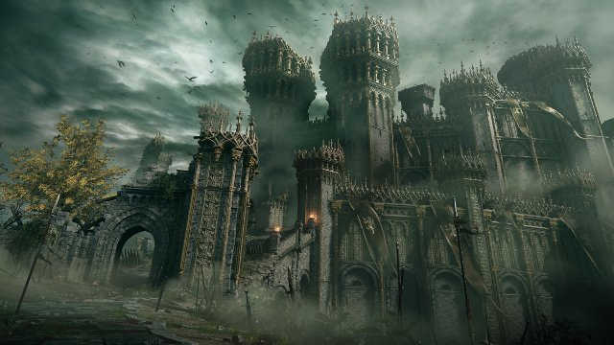

You now make your way back to the plaza where you once fell, ready to face that creature again. You cross the wooden bridge, and stand in front of a statue situated in the middle of the square. Soon enough, the same screeching sound and loud crash is heard behind you.

If you have the sword:

You take out your weapon, and ready yourself for the fight. The beast you have to face also has weapons, this will be a complicated fight.

20) The fights begin. (go to page 54)

61

14) You touched a random book and it opened a secret passage. The cellar is damp and cold, revealing forgotten wine barrels and hidden passages. You're now walking slowly and surely in these passages. There is a sign saying “Don't go further!”

18) You decide to not listen to the sign and go further (Go to page 67)

18) You can't go back now. Go further. (Go to page 67)

62

19) The chest looks like a great way to get something useful. Maybe a weapon, or a key… or a hint. You start to relish in thinking about what could lie inside the chest. After thinking about it for a while, you finally decide to open it.

You lift the top part, only to be attacked by the chest. Two arms spring out of the inside, pulling you inside its gaping mouth. Even as you try to fight back, the chest closes trapping you inside.

YOU DIED. (go back to the beginning.)

63

15) You approach them slowly. As you investigate the ballroom, ghostly dancers materialize. They're all saying that they can find the exit for you, because you seem desperate.

19) You decide to trust them because they look human enough. (Go to page 68)

20) You decline their offer. (Go to page 69)

64

16) They helped you and they were kind souls. For a moment, you were scared by all the stories they were telling you. But you were more traumatized by the experience you actually lived. You went back home in your world after that, and you never felt the same. But congratulations. I guess.

65

17) They all understood your choice, but you got lost in the woods without any help. You couldn't eat for days or neither drink water. You died.

66

18) You found the way out ! You made it back safely. Professor Samuel was looking for you, he wanted answers. Which door did you choose? How was it inside ? Who did you meet? It was like he already knew and planned everything…

67

19) They were all in your head. They never existed and you were just going insane. You got stuck in this world and never made it back.

68

20) We all make mistakes sometimes. Try again or you're never going to make it…

69